Extra Practical :- 1
AIM :- Develop a PHP web application to create a job application form where candidates can enter details such as name, email, qualification, and experience. After submission, the application should display all the entered details to the user.

INPUT Files :-

File - 1:- { index.php }
<!DOCTYPE html>
<html>
<head>
<title>Job Application Form</title>
<link rel="stylesheet" href="style.css">
</head>
<body>

<h2>Job Application Form</h2>

<form action="submit.php" method="POST">

<label>Name:</label><br>
<input type="text" name="name" required><br><br>

<label>Email:</label><br>
<input type="email" name="email" required><br><br>

<label>Qualification:</label><br>
<input type="text" name="qualification" required><br><br>

<label>Experience (in years):</label><br>
<input type="number" name="experience" required><br><br>
<input type="submit" value="Submit">

</form>
</body>
</html>

File - 2 :- { submit.php }
<!DOCTYPE html>
<html>
<head>
<title>Application Submitted</title>
</head>
<body>

<h2>Submitted Details</h2>

<?php
if ($_SERVER["REQUEST_METHOD"] == "POST") {

// Collect data
$name = htmlspecialchars($_POST['name']);
$email = htmlspecialchars($_POST['email']);
$qualification = htmlspecialchars($_POST['qualification']);
$experience = htmlspecialchars($_POST['experience']);

echo "<p><strong>Name:</strong> $name</p>"; echo "<p><strong>Email:</strong> $email</p>";
echo "<p><strong>Qualification:</strong> $qualification</p>"; echo "<p><strong>Experience:</strong> $experience years</p>";

} else {
echo "No data submitted.";
}
?>

<br>
<a href="index.php">Go Back</a>

</body>
</html>

OUTPUT:-
- Home page
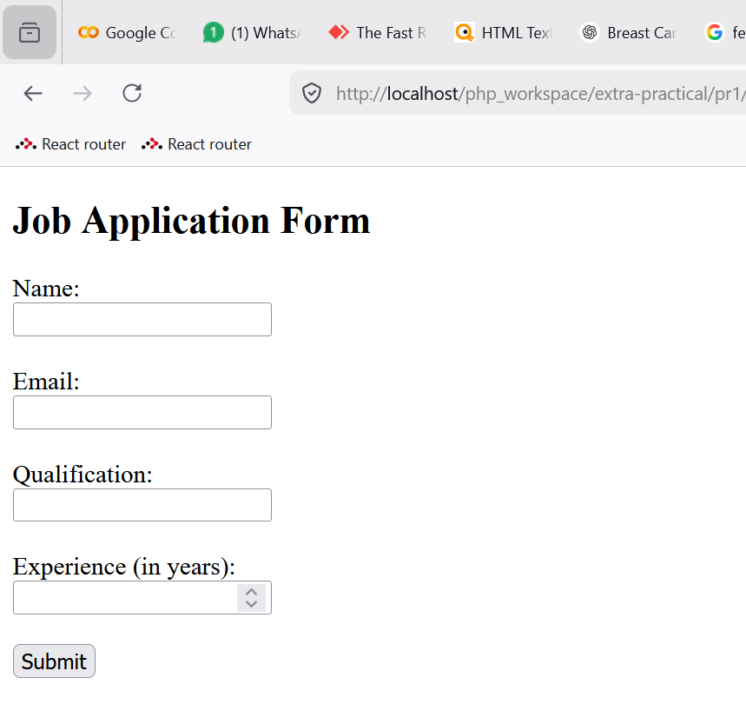
- Inputing the job details
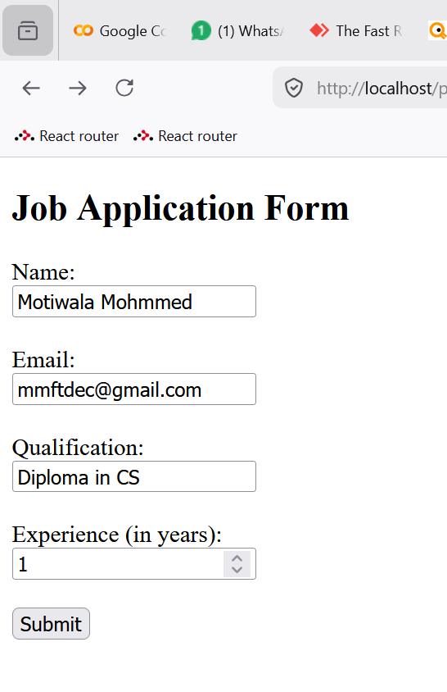

- Output with candidate details
